**Motor Driver IC**

A motor driver IC is an integrated circuit chip which is usually used to control motors in autonomous robots. Motor driver ICs act as an interface between microprocessors in robots and the motors in the robot. The most commonly used motor driver IC’s are from the L293 series such as L293D, L293NE, etc. These ICs are designed to control 2 DC motors simultaneously. L293D consist of two H-bridge. H-bridge is the simplest circuit for controlling a low current rated motor.

L293D has 16 pins, they are comprised as follows:  
Ground Pins - 4  
Input Pins - 4  
Output Pins - 4  
Enable pins -  2  
Voltage Pins - 2

#### Motor Driver Operation

#### The L293D IC receives signals from the microprocessor and transmits the relative signal to the motors. It has two voltage pins, one of which is used to draw current for the working of the L293D and the other is used to apply voltage to the motors. The L293D switches it output signal according to the input received from the microprocessor.

#### For Example: If the microprocessor sends a 1(digital high) to the Input Pin of L293D, then the L293D transmits a 1(digital high) to the motor from its Output Pin. An important thing to note is that the L293D simply transmits the signal it receives. It does not change the signal in any case.

#### L293D And Its Working

#### The L293D is a 16 pin IC, with eight pins, on each side, dedicated to the controlling of a motor. There are 2 INPUT pins, 2 OUTPUT pins and 1 ENABLE pin for each motor. L293D consist of two H-bridge. H-bridge is the simplest circuit for controlling a low current rated motor.

#### Working Of A H-bridge

H-bridge is given this name because it can be modelled as four switches on the corners of ‘H’. The basic diagram of H-bridge is given below:

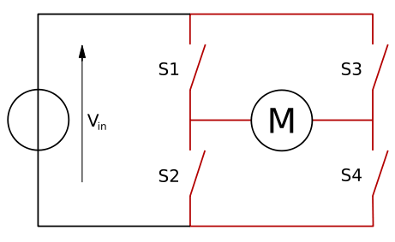

In the given diagram, the arrow on the left points to the higher potential side of the input voltage of the circuit. Now if the switches **S1** & **S4** are kept in a **closed** position while the switches **S2** & **S3** are kept in a **open** position meaning that the circuit gets shorted across the switches **S1** & **S4**.  This creates a path for the current to flow, starting from the V input to switch **S1** to the **motor**, then to switch **S4** and then the exiting from the circuit. This flow of the current would make the motor turn in one direction. The direction of motion of the motor can be clockwise or anti-clockwise, this is because the rotation of the motor depends upon the connection of the terminals of the motor with the switches.

**Coding With PWM**

# Arduino and L298N

|  |
| --- |
| #define enA 9  #define in1 6  #define in2 7  #define button 4  int rotDirection = 0;  int pressed = false;  void setup() {  pinMode(enA, OUTPUT);  pinMode(in1, OUTPUT);  pinMode(in2, OUTPUT);  pinMode(button, INPUT);  // Set initial rotation direction  digitalWrite(in1, LOW);  digitalWrite(in2, HIGH);  }  void loop() {  int potValue = analogRead(A0); // Read potentiometer value  int pwmOutput = map(potValue, 0, 1023, 0 , 255); // Map the potentiometer value from 0 to 255  analogWrite(enA, pwmOutput); // Send PWM signal to L298N Enable pin  // Read button - Debounce  if (digitalRead(button) == true) {  pressed = !pressed;  }  while (digitalRead(button) == true);  delay(20);  // If button is pressed - change rotation direction  if (pressed == true & rotDirection == 0) {  digitalWrite(in1, HIGH);  digitalWrite(in2, LOW);  rotDirection = 1;  delay(20);  }  // If button is pressed - change rotation direction  if (pressed == false & rotDirection == 1) {  digitalWrite(in1, LOW);  digitalWrite(in2, HIGH);  rotDirection = 0;  delay(20);  }  } |